Course: MENG 2020 Computer Programming
Lab: Lab 02
Name: Michael McCorkell | Student ID: N01500049
Date: September 26th 2026

Please refer to the lab manual posted on the blackboard and fill in the following table as your final lab report.

Please Notice: All the labs are individual work and submission. All academic misconduct behaviors will be penalized the maximum extent possible according to college policy. Thanks for your attention. (Reference Link: About Academic Misconduct)

Please finish all the lab report submission requirements in the following table. Add more rows if necessary.

Lab Results
Lab Procedures | Submission Requirements: Please submit screenshots showing your original Matlab code and the execution results for each step.  Note: If file submission is required, please attach your files separately on Blackboard.
Chapter 2, Q1 | 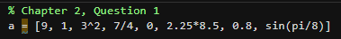
Chapter 2, Q3 | 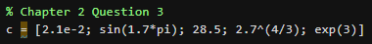  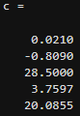
Chapter 2, Q5 | 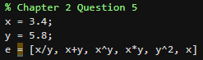  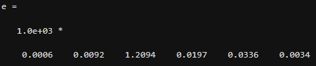
Chapter 2, Q7 | 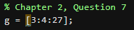  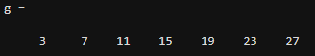
Chapter 2, Q9 | 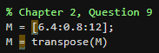  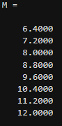
Chapter 2, Q11 | 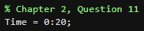  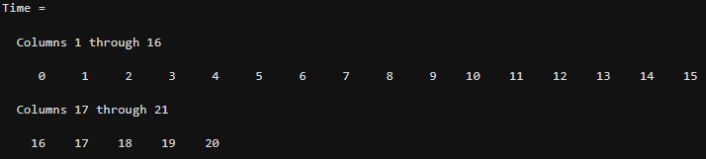
Chapter 2, Q13 | 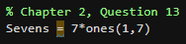  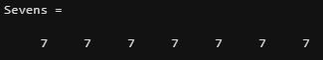
Chapter 2, Q15 | 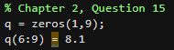
Chapter 2, Q21 a & b | 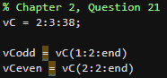  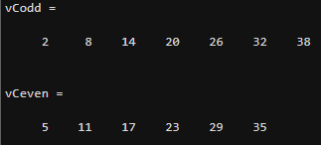
Chapter 2, Q23 | 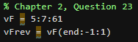  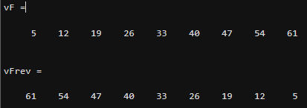
Chapter 3, Q1 | 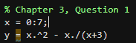
Chapter 3, Q2 | 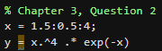  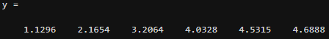
Chapter 3, Q3 | 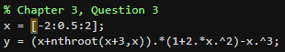

After Lab Practice Questions
Your solutions:
